PRESS INFORMATION FROM THE SEEWAY TRUST

Ukraine Children's Feeding Programme

The Seeway Trust get involved!

The Seeway Trust are an Exeter based Christian run charity, whose members are dedicated to helping children who live in impoverished areas of the world. Their vision is to see people but primarily children, rescued from poverty and given the opportunity to grow up and live a life useful to the society in which they live.

Following a visit to the Ukraine by local preacher Rev Tom Thompson, the Seeway Trust became involved with a Christian church in Zhitomir where Pastor Vasily is running a feeding program for local children.

The Church has a number of branches and under Pastor Vasily feeds about 300 children one good meal a day for five days a week. The children that are fed are members of very poor families, many are one parent, and some children are being raised by elderly grandparents.

For many living in this area the normal diet is extremely poor, usually consisting of potatoes, rice or pasta. One family of nine children that the pastor visited were cooking pasta and bones. The children do not look malnourished compared with scenes we have seen on the television, but the children are stunted in growth and susceptible to disease such as TB which is now at epidemic proportions in their country.
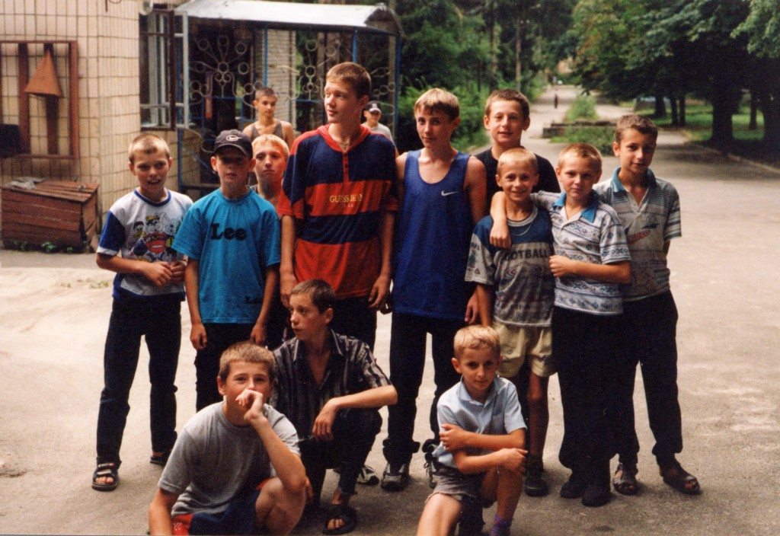
In August 2001 a team of six people including three from the Riverside Christian Centre and three from the Church on the Rock in St Ives, Cornwall, visited Zhitomir in Ukraine and Pastor Vasily's church. Although over the last year, the Seeway Trust has been sending some money to the church - in order to help them with their feeding programme, the aim of this visit was to see how more of the children could be fed by helping the church to produce their own food.

The three Exeter members were Rev Tom Thompson who is a builder as well as a preacher, he led the team and was there to advise with his knowledge of building. Emmerson Skinner a very experienced Devon farmer was there to give advice regarding agriculture. Emmerson has for many years visited Christians in Eastern Europe and had already plenty of local knowledge. George Bainborough the founder of the Seeway Trust was the third Exeter member of the team and was there to oversee negotiations with their local church and see how the Seeway Trust could become more involved with this project. The St Ives friends were John Gilmore, an elder and businessman, Stuart Mackin a worship leader who went as an observer regarding alcohol and drug abuse, and lastly Sheila Stone a mother who's main concern was the care of the children.

Tom reports -

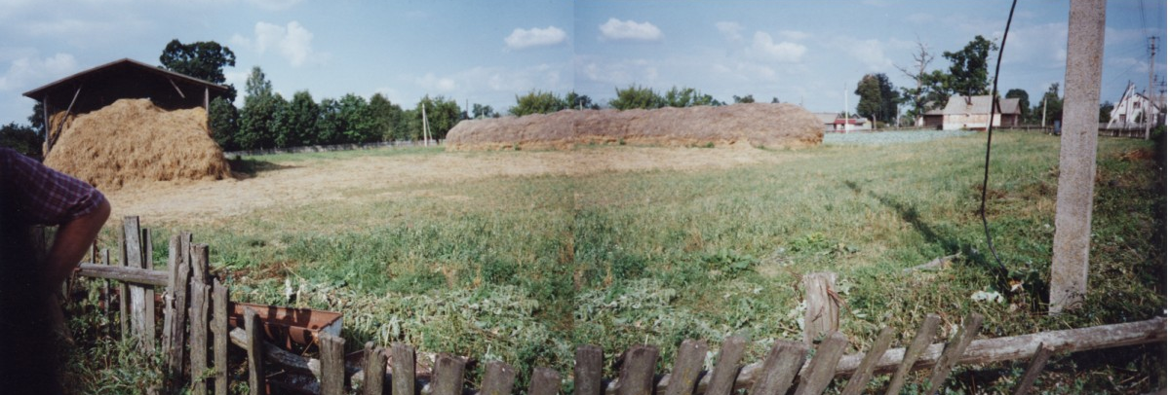
With a project like this there are so many things to consider. Up until now we have only been able to send enough money to feed twenty of these three hundred children. We soon realised that it would be far better if we could help the people out there to set up a means of helping to produce food themselves.

By the end of the weeks visit, we had seen a number buildings and land. On the last afternoon of our stay we spoke with one of the leaders of a village which is situated close to a Sanatorium (a very basic health recovery centre) and are in negotiations with them to obtain land and buildings, where we intend to produce meat, eggs and vegetables for the needy children.

Because a project such as this requires equipment, livestock and arable crops, at the moment Seeway are having to study the export and import regulations of both the UK and the Ukraine. Some of the stock and equipment needed may well be available in the Ukraine already, but again these are things that need to be found out about!

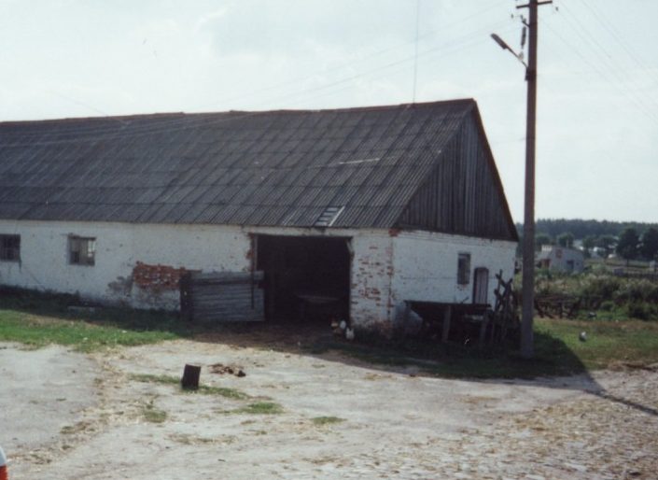
Emmerson Skinner who is co-ordinating the agricultural part of this project commented "We have already made a small start in that we have obtained a very large shed, but are now trying to purchase some land nearby to grow wheat. Animals are needed to produce the protein - in the form of meat and eggs, which the children are so sadly lacking in their diet. Our aim is to use the wheat to feed chickens and pigs. But we have yet to obtain any livestock or arable crop and also much equipment is needed."

Although the setting up costs of this project will be relatively low, - they still have to be found. It is to this end that members of the Seeway Trust are praying that individuals and groups who may be able to help them with the Ukraine project, either with advice, financial, or by donating equipment and other items that could be used to help set up or run this type of agricultural development, will come forward. Even old farm equipment, which may be of no further use in the UK, may be ideal for a project of this nature in the Ukraine.

If anyone can provide agricultural help, Emmerson would be pleased to hear from you, he can be contacted on 01769 581046

This registered charity is not only a non-profit making organisation, it is entirely run by volunteers, who take their own holidays to oversee the work in their children's rescue homes -

Seeway are aware how some people feel about giving money to charity, although hearts and minds are willing to give to good causes, many fear that little of their generous gift will actually get through! George Bainborough the founder of the Seeway Trust refreshingly pointed out that 'all' of the money which is donated to Seeway goes to the children. "We take out nothing, all our trustees, board members and helpers, are volunteers who burn with desire to held children who are desperately impoverished. We take no pay, not even our expenses are taken from the donations. We take our holidays to make visits and oversee our children's rescue homes, and the other operations that we are involved in abroad, which includes Ghana, Indian and of course now the Ukraine.

A lot of people are unaware that if benefactors covenant their gifts and donations, the UK government reimburse the charity involved any tax paid to earn that entitlement in the first place. At the moment the Seeway Trust's running costs are less than 3%. Currently this 'refund' from the government covers all Seeway's essential costs where necessary. Therefore allowing 100% of donated money to go to where it is most needed, - to feed, clothe, shelter and educate children in their care.

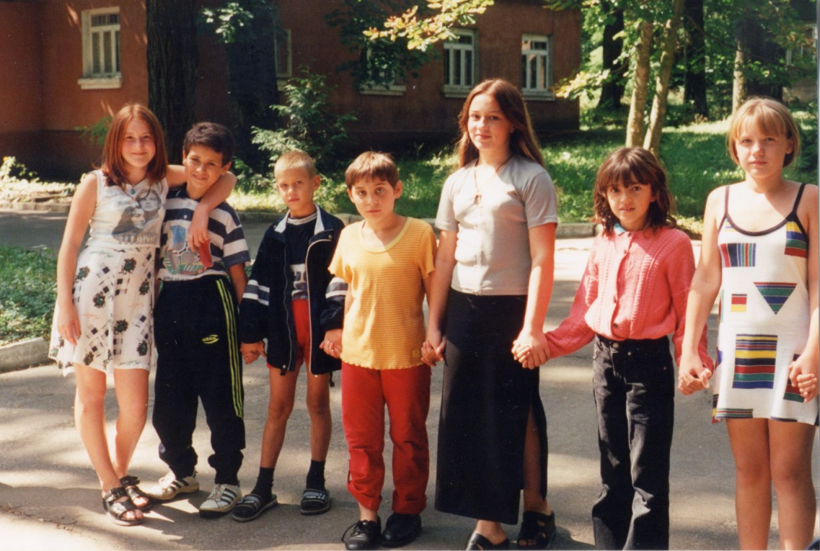
Finally George pointed out that for as little as £5, a child in the Ukraine can be fed one square meal a day for five days a week for a whole month!

Further information on the work of the Seeway Trust and some of their other projects, is available from their website at - www.seewaytrust.org

Or contact them by telephone 01392 466 467, or email - seewaytrust@onetel.net

SEEWAY TRUST - Registered Charity No. 1074868.
Seeway Trust, Ford House, Eggesford, Chulmliegh. Devon. EX18 7JY.

END

